Role of Iodine in Thyroid Hormone Synthesis
Pooja Venkatesh
Agnes Scott College

Central to the role of the thyroid endocrine gland is the secretion of triiodothyronine (T₃) and thyroxine (T₄) hormones, responsible for regulation of cellular metabolism. Normal functioning of this hormonal system is heavily dependent on the element iodine, a micronutrient crucial for T₃/T₄ production. The following paper is a review on the biochemical mechanism for iodide uptake, oxidation, and coupling of iodinated tyrosine residues to secrete T₃ and T₄ into systemic circulation. Although this biochemical pathway has been well characterized, several mechanisms remain unknown. Additional elucidation of this process will aid in the identification of new drug targets and medical treatments for thyroid-related disorders.

T
he biosynthetic pathway of thyronine synthesis is shown below in Figure 1.¹ The process begins with iodide import into thyroid epithelial cells and export into the follicular lumen. Oxidation, organification, and coupling reactions are then catalyzed to incorporate iodine atoms onto thyroglobulin (Tg) molecules, which are then endocytosed back into the thyrocyte. Tg protein degradation releases thyroxine and triiodothyronine which can then be secreted out of the thyroid into the bloodstream.

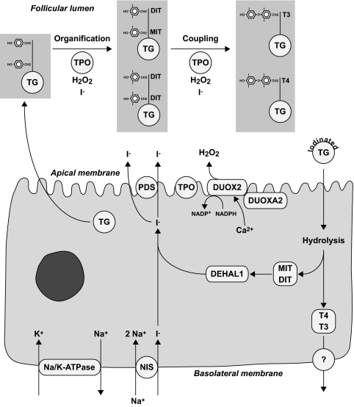
Figure 1: Depiction of the Thyroid Hormone Biosynthetic Pathway ¹

The majority of discoveries regarding the biosynthetic pathway were made in the 20th century starting with the cloning of the Na⁺/I⁻ symporter (NIS). This protein channel, cloned in 1996, initiates the first step of hormone synthesis by importing iodide into thyrocytes.² Pendrin, the I⁻ transporter localized to the apical cell membrane, was identified following studies of the genetic mutation that caused Pendred syndrome in 1997.³ Thyroid peroxidase (TPO), the enzyme that catalyzes the iodination and conjugation reactions on Tg molecules, was purified and identified in 1988, however questions remain as to the mechanisms of the reactions catalyzed.⁴ Although it was suggested in 1971 that H₂O₂ was produced at the apical membrane and required for TPO function, it was not until 1999 that the responsible enzyme, DUOX2, was identified.⁵ In 1982, proposed mechanisms for the oxidation of iodine prior to organification were published, however the exact oxidized species is still not confirmed.^{6, 7} Oxidized iodine is then added to tyrosine residues on thyroglobulin (iodination) and adjacent residues are coupled in a phenoxy ether conjugation reaction. The substrates, products, and kinetics for the TPO-catalyzed reactions were first determined in 1981 as part of investigating medical therapies for thyroid disorders.^{4, 8} Resultant Tg is then endocytosed, degraded, and T₃/T₄ secreted out of the cell. By the 21st century the entire pathway was well defined.
Although the central molecules and enzymatic reactions of thyroid hormone synthesis are established, several mechanisms of enzyme action remain to be investigated. For instance, conflicting data exists concerning thyroid peroxidase tyrosine selectivity and conjugation kinetics as well as the iodine species produced after TPO oxidation. Increased elucidation of this pathway will fuel the development of more effective medical treatments for thyroid disorders and the identification of novel drug targets.

Discussion
Located near the trachea, the bilobed thyroid endocrine gland functions to regulate hormone synthesis. Stimulation by the pituitary hormone thyrotropin, TSH, activates thyronine synthesis at the follicle. This central structure is composed of a set of epithelial cells surrounding a colloidal space in a circular manner.⁹ Follicular basolateral membranes face blood plasma for iodide uptake while their apical membranes face the colloidal lumen. The primary role of the thyroid endocrine gland is the production of triiodothyronine (T₃) and thyroxine (T₄) hormones. The functional hormones, once secreted out of the thyroid, bind to cells and trigger changes in gene expression, affecting a plethora of cellular processes.⁹ These hormonal regulations of cellular metabolism in vertebrate species are essential to normal maturation and structural development.^{2, 10,11}
The limiting reagent in the synthesis of these two molecules (see Figure 2) is the heavy element iodine in its anionic form, I⁻.¹² The biochemical role of this element revolves around its requirement in T₃ and T₄ hormone production. Iodine is a diatomic, group 7A, nonmetal halogen with an atomic weight of 126.90 amu. At room temperature, molecular iodine is a blue-black solid with a strong odor whose melting and boiling points are 133.5°C and 185°C, respectively.¹³ Iodine deficiency is the most common endocrinopathy in the world and most preventable cause of mental defects.¹⁴ Average current intake of iodine obtained from diet in the United States is about 150 µg per day.⁷ Approximately 70-80% of iodide within the body is localized to the thyroid gland where incorporation into thyroglobulin tyrosine residues occurs.¹² Iodination is essential to the biological function of thyroid hormones and makes up 65% of the molecular weight of T₄ and 58% molecular weight of T₃.⁷ Thyroid hormone synthesis begins with dietary intake of iodine, absorption in the small intestine, and transport of I⁻ through the bloodstream to thyroid follicular cells.⁷ Transport into the follicular cells is mediated by the Na⁺/I⁻ symporter, after which oxidation, organification, and coupling reactions result in the final production of iodothyronines.¹²

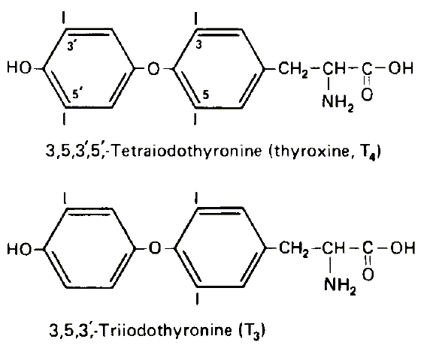
Figure 2: Structure of T₃ and T₄ ¹⁵

The first step of iodothyronine synthesis, I⁻ uptake, is mediated by the transmembrane glycoprotein sodium/iodide symporter (NIS) localized to the basolateral cell membrane.¹⁰ This sodium-dependent channel transports iodide from the bloodstream into thyroid follicular cells by means of the Na⁺ gradient established by the Na⁺/K⁺ ATPase pump.¹² NIS works by a secondary active transport mechanism such that two Na⁺ ions are imported for every I⁻ anion - a net positive influx.¹⁰ Functionality of the NIS is dependent on energy, O₂ levels, and a Na⁺ electrochemical gradient across the basolateral membrane.⁷ After an initiating Na⁺ cation binds to the transporter, an NIS-Na₂I complex forms which is transported into the cytoplasm.¹⁶ Following I⁻ import, the glycoprotein pendrin, an anion exchanger of the SLC26A family, transports I⁻ out of the follicular cell by passive movement across the apical cell membrane into the follicular lumen where the organification reactions take place.^{1, 17} However, pendrin is considered only a potential transporter, as there have been no direct demonstrations of iodide efflux by pendrin into the follicular lumen.⁷
The follicular lumen is a colloidal fluid mainly composed of thyroglobulin proteins secreted from thyrocyte endoplasmic reticuli.² Once I⁻ has been localized to the follicular lumen, thyroid peroxidase (TPO) catalyzes the oxidation of iodide, the iodination of tyrosine residues on thyroglobulin (Tg), and the conjugation reactions of adjacent 3-monoiodotyrosine (MIT) and 3,5-diiodotyrosine (DIT) residues to form T₃ and T₄. The heme group present in TPO is necessary for formation of the enzyme-substrate complex.⁷ The first TPO-catalyzed reaction requires H₂O₂ secreted into the lumen by the NADPH-dependent enzyme, DUOX2, which is localized to the follicular apical membrane.¹ TPO, along with H₂O₂, oxidizes lumen I⁻ so it may then be incorporated into selected tyrosine residues on the dimeric glycoprotein thyroglobulin.² Multiple proposals exist as to what the oxidized intermediate is: an iodine radical, a TPO-I⁺ complex, or I₂.^{7, 18} This Tg-iodination reaction adds iodine atoms onto Tg tyrosyl residues, ortho to the tyrosine hydroxyl group, resulting in the formation of MIT residues. If iodination is catalyzed by TPO twice on the same tyrosine residue, DIT is formed, as shown in Figure 3.^{19, 20}

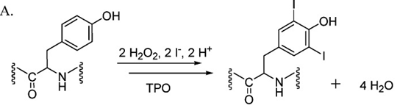
Figure 3: Organification of Tyrosine Residues on Thyroglobulin ²¹

Although often presented as sequential steps, iodination and coupling are simultaneously catalyzed by TPO as shown in Figure 4. This pH-dependent coupling reaction of MIT or DIT residues to form T₃ or T₄ is catalyzed by the oxoferryl porphyrin pi-cation radical form of the enzyme.²² A phenoxy ether bond is formed either between adjacent MIT and DIT or between two DIT residues. Conjugation of MIT and DIT residues forms T₃ while conjugation of two DIT residues forms T₄. The ether bond is formed between the hydroxyl group of an acceptor tyrosyl residue and the iodophenol group of a donor tyrosyl.⁷ One proposed coupling mechanism involving iodotyrosine radicals is shown in Figure 5.⁷

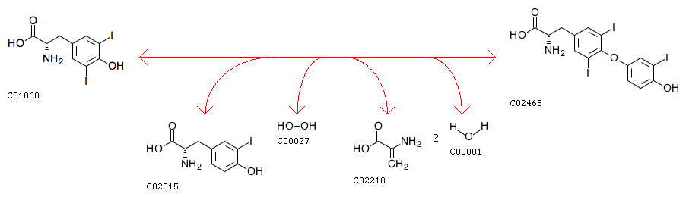

Figure 4: TPO-Catalyzed Organification and Coupling Reactions on Tyrosine Residues ²³

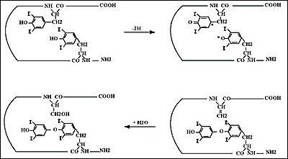

Figure 5: Potential Radical Mechanism for TPO-Catalyzed DIT Coupling ⁷

Studies have demonstrated that this coupling reaction is not enzyme-specific.^{24, 25} For example, other heme-containing peroxidases apart from TPO, such as lactoperoxidase, have catalyzed the same reaction in vitro.²⁴
Following the organification and coupling reactions, lumenal thyroglobulin is then endocytosed into the follicular cell by either a TSH-mediated coated vesicle mechanism or by micropinocytosis.²⁶ Tg-containing vesicles can then be trafficked through multiple pathways, one of which consists of sorting through the early apical endosome, late endosome, and lysosome. Release of the T₃ and T₄ hormones from thyroglobulin occurs after proteolytic cleavage of the molecule in the lysosome.
About 10% of T₄ is converted to T₃ by a deiodination reaction catalyzed by the selenocysteine containing enzyme, iodothyronine 5’ deiodinase.^{7, 27} The selenolate group on the enzyme reacts with the T₄ prohormone and forms a selenenyl-iodide intermediate. The enzyme intermediate then reacts with an unknown cofactor regenerating its original catalytic form.^{27, 28} Having finally synthesized T₃ and T₄, the thyroid secretes the hormones from the follicular cells into blood plasma by passive diffusion across the basolateral membrane.⁷
Ultimately, iodine plays an essential role in thyroid hormone synthesis. The pathway, illustrated in Figure 1, begins with I⁻ uptake into thyrocyte cells by the NIS channel. The anion is then transported out of the cell by pendrin and incorporated onto tyrosine residues on thyroglobulin by thyroid peroxidase. TPO simultaneously catalyzes the coupling of adjacent iodinated residues such that the resultant thyroglobulin molecule may be endocytosed into the follicular cell. Following lysosomal degradation of Tg, T₃ and T₄ hormones may be secreted out of the thyroid epithelial cells. Synthesized T₄, prior to secretion, may also be deiodinated to form T₃. Once secreted to the blood plasma, the hormones can then elicit biological responses in target cells. While the process has been established, absolute knowledge of this pathway has not yet been obtained.

Conclusion
Despite being a highly characterized pathway, thyroid hormone synthesis is still not entirely elucidated. Further research will need to be conducted to determine whether pendrin is truly the transport protein responsible for I⁻ efflux. Patients with Pendred syndrome have a non-functional pendrin protein, but show only minor negative effects on thyroid function.⁷ Similarly, genetically engineered mice with PDS knockout (pendrin-encoding gene) also show normal thyroid function.⁷ Since pendrin has never been directly demonstrated to be the I⁻ efflux protein, other transport mechanisms may exist.
Additional studies are also needed to investigate the mechanisms and kinetics of thyroid peroxidase. Several conflicting proposals on the nature of the oxidized species produced by TPO and H₂O₂ exist, including I₂, an iodine radical, OI⁻, and TPO-I⁺.^{7, 18, 29, 30} Likewise, the mechanism by which TPO identifies only selected tyrosine residues (hormonogenic sites) on thyroglobulin for organification remains poorly defined as well as the mechanism for the Wolff Chaikoff effect - the phenomenon that excessive iodine inhibits thyroid hormone synthesis.^{31, 32} Similarly, the cofactors used by iodothyronine 5’ deiodinase to convert T₄ to T₃ remain unknown but is a subject of interest in understanding intracellular or potentially drug-induced regulation of the enzyme.^{27, 28}
After thyroglobulin endocytosis, coat protein mediated trafficking and transport vesicle sorting direct Tg through several intracellular pathways. Research is actively determining the involved regulatory molecules, vesicle membrane receptors, and additional proteins involved in this complicated network. Following vesicle trafficking and Tg proteolytic cleavage in the lysosome, T₄ and T₃ hormones have long been thought to freely diffuse out of the follicular basolateral cell membrane. However, iodothyronines are charged at their amino acid side chains and therefore may be exiting the cell via unidentified membrane transporters rather than diffusion across a hydrophobic lipid bilayer.⁷
Ultimately, understanding the intricacies of this biosynthetic pathway will aid researchers in determining new drug targets and more effective drug therapies for thyroid-related disorders. Thyroid illnesses plague a large percentage of the world population such that there will always be a high demand for new medications, greater target selectivity, and more cost effective treatments.

References
- Bizhanova, A., & Kopp, P. (2009). The Sodium-Iodide Symporter NIS and Pendrin in Iodide Homeostasis of the Thyroid. Endocrinology,150(3), 1084-1090. doi:10.1210/en.2008-1437
- Portulano, C., Paroder-Belenitsky, M., & Carrasco, N. (2014). The Na /I−Symporter (NIS): Mechanism and Medical Impact. Endocrine Reviews,35(1), 106-149. doi:10.1210/er.2012-1036
- Witherly, J. Altered Gene Causes Pendred Syndrome: Finding Leads to Better Understanding of Deafness https://www.genome.gov/10000666/1997-news-release-pendred-syndrome-gene/. Retrieved March 21, 2017.
- Doble, N. D., Banga, J. P., Pope, R., Lalor, E., Kilduff, P., & McGregor, A. M. (1988). Autoantibodies to the thyroid microsomal/thyroid peroxidase antigen are polyclonal and directed to several distinct antigenic sites. Immunology,64(1), 23-29. Retrieved March 21, 2017.
- Dupuy, C., Ohayon, R., Valent, A., Noël-Hudson, M., Dème, D., & Virion, A. (1999). Purification of a Novel Flavoprotein Involved in the Thyroid NADPH Oxidase. Journal of Biological Chemistry,274(52), 37265-37269. doi:10.1074/jbc.274.52.37265
- Ohtaki, S., Nakagawa, H., Nakamura, M., & Yamazaki, I. (1982). One- and Two-electron Oxidations of Tyrosine, Monoiodotyrosine, and Diiodotyrosine Catalyzed by Hog Thyroid Peroxidase. Journal of Biological Chemistry,257(22), 13398-13403. Retrieved March 21, 2017.
- Rousset, B. (2015, September 02). Chapter 2 Thyroid Hormone Synthesis And Secretion. Retrieved March 21, 2017, from https://www.ncbi.nlm.nih.gov/books/NBK285550/
- Niazi, A., Irfan, A., Kalra, S., & Islam, A. (2011). Thyroidology over the ages. Indian Journal of Endocrinology and Metabolism,15(6), 121-126. doi:10.4103/2230-8210.83347
- Nussey, S. (1970, January 01). The thyroid gland. Retrieved March 21, 2017, from https://www.ncbi.nlm.nih.gov/books/NBK28/
- Alotaibi, H., Tuzlakoğlu-Öztürk, M., & Tazebay, U. H. (2016). The Thyroid Na /I- Symporter: Molecular Characterization and Genomic Regulation. Molecular Imaging and Radionuclide Therapy,26(Suppl 1), 92-101. doi:10.4274/2017.26.suppl.11
- Galusova, A., Pauliny, M., Majek, M., Mackova, J., Meskova, M., Vlcek, M., . . . Penesova, A. (2015). Dynamic neuroendocrine changes in critically ill patients with polytrauma. Neuroendocrinology Letters,36(5), 498-503. Retrieved March 21, 2017.
- Pesce, L., & Kopp, P. (2014). Iodide transport: implications for health and disease. International Journal of Pediatric Endocrinology,2014(1), 8. doi:10.1186/1687-9856-2014-8
- Iodine. (n.d.). Retrieved March 21, 2017, from https://pubchem.ncbi.nlm.nih.gov/compound/807
- Ahad, F., & Ganie, S. A. (2010). Iodine, Iodine metabolism and Iodine deficiency disorders revisited. Indian Journal of Endocrinology and Metabolism, 14(1), 13–17.
- L, H., & Van Schalkwyk, J. (n.d.). Thyroid physiology and tests of function. Retrieved March 21, 2017, from http://www.anaesthetist.com/icu/organs/endocr/thyroid/Findex.htm#thyfx.htm
- Eskandari, S., Loo, D. D., Dai, G., Levy, O., Wright, E. M., & Carrasco, N. (1997). Thyroid Na /I− Symporter Mechanism, Stoichiometry, and Specificity. Journal of Biological Chemistry,272, 27230-27238. doi:10.1074/jbc.272.43.27230
- Bizhanova, A., & Kopp, P. (2009). The Sodium-Iodide Symporter NIS and Pendrin in Iodide Homeostasis of the Thyroid. Endocrinology, 150(3), 1084–1090. http://doi.org/10.1210/en.2008-1437
- Ohtaki, S., Nakagawa, H., Kimura, S., & Yamazaki, I. (1981). Analyses of Catalytic Intermediates of Hog Thyroid Peroxidase during Its Iodinating Reaction. Journal of Biological Chemistry,256(2), 805-810. Retrieved March 21, 2017.
- Antoniadis, Constantinos D., Corban, Ghada J., Hadjikakou, Sotiris K., Hadjiliadis, N., Kubicki, M., Warner, S. and Butler, Ian S. (2003), Synthesis and Characterization of (PTU)I2(PTU = 6-n-propyl-2-thiouracil) and (CMBZT)I2 (CMBZT = 5-chloro-2-mercaptobenzothiazole) and Possible Implications for the Mechanism of Action of Anti-Thyroid Drugs. Eur. J. Inorg. Chem., 2003: 1635–1640. doi:10.1002/ejic.200390215
- Magnusson, R. P., Taurog, A., & Dorris, M. L. (1984). Mechanisms of thyroid peroxidase- and lactoperoxidase-catalyzed reactions involving iodide. Journal of Biological Chemistry,259(22), 13783-13790. Retrieved March 21, 2017.
- Blasiak, L. C., & Drennan, C. L. (2009). Structural Perspective on Enzymatic Halogenation. Accounts of Chemical Research, 42(1), 147–155. http://doi.org/10.1021/ar800088r
- Doerge, D. R., & Divi, R. L. (1995). Porphyrin π-cation and protein radicals in peroxidase catalysis and inhibition by anti-thyroid chemicals. Xenobiotica,25(7), 761-767. doi:10.3109/00498259509061891
- Orthology: K00431 http://www.genome.jp/dbget-bin/www_bget?K00431%2B1.11.1.8%
2BR03953. Retrieved March 21, 2017.
- Vijlder, J. D., & Hartog, M. D. (1998). Anionic iodotyrosine residues are required for iodothyronine synthesis. European Journal of Endocrinology,138(2), 227-231. doi:10.1530/eje.0.1380227
- Taurog, A., Dorris, M. L., & Doerge, D. R. (1996). Mechanism of Simultaneous Iodination and Coupling Catalyzed by Thyroid Peroxidase. Archives of Biochemistry and Biophysics,330(1), 24-32. doi:10.1006/abbi.1996.0222
- Bernier-Valentin, F., Kostrouch, Z., Rabilloud, R., Munari-Silem, Y., & Rousset, B. (1990). Coated vesicles from thyroid cells carry iodinated thyroglobulin molecules. First indication for an internalization of the thyroid prohormone via a mechanism of receptor-mediated endocytosis. Journal of Biological Chemistry,265(28), 17373-17380. Retrieved March 21, 2017.
- Berry, M. J., Banu, L., & Larsen, P. R. (1991). Type I iodothyronine deiodinase is a selenocysteine-containing enzyme. Nature,349(6308), 438-440. doi:10.1038/349438a0
- Roy, G., & Mugesh, G. (2006). Bioinorganic Chemistry in Thyroid Gland: Effect of Antithyroid Drugs on Peroxidase-Catalyzed Oxidation and Iodination Reactions. Bioinorganic Chemistry and Applications, 2006, 23214. http://doi.org/10.1155/BCA/2006/23214
- Cahnmann, H. J., Pommier, J., & Nunez, J. (1977). Spatial requirement for coupling of iodotyrosine residues to form thyroid hormones. Proceedings of the National Academy of Sciences,74(12), 5333-5335. doi:10.1073/pnas.74.12.5333
- Ohtaki, S., Nakagawa, H., Nakamura, M., & Yamazaki, I. (1982). Reactions of purified hog thyroid peroxidase with H2O2, tyrosine, and methylmercaptoimidazole (goitrogen) in comparison with bovine lactoperoxidase. Journal of Biological Chemistry,257(2), 761-766. Retrieved March 21, 2017.
- Markou, K., Georgopoulos, N., Kyriazopoulou, V., & Vagenakis, A. (2001). Iodine-Induced Hypothyroidism. Thyroid,11(5), 501-510. doi:10.1089/105072501300176462
- Xiao, S., Dorris, M. L., Rawitch, A. B., & Taurog, A. (1996). Selectivity in Tyrosyl Iodination Sites in Human Thyroglobulin. Archives of Biochemistry and Biophysics,334(2), 284-294. doi:10.1006/abbi.1996.0457

